The Churches of Coxley with Godney, Henton & Wookey

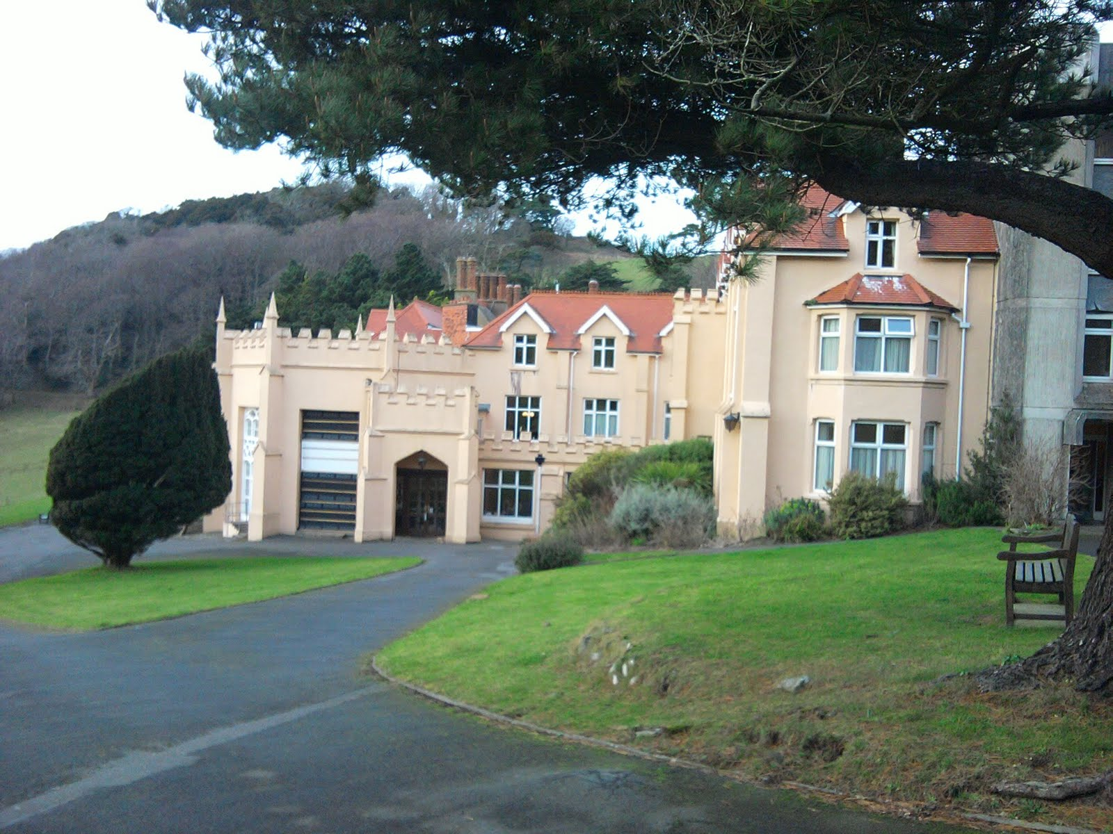

Come and Join Us
for a
Weekend Away
at
Lee Abbey!
A lot goes on at our churches, with many different services and activities. We are organising a weekend away so that we can get together and strengthen relationships, meet people from other areas of church life, worship and have fun!

The programme for the weekend will be developed and realised nearer the time but will include special services, children’s activities and social time together. We will be taking over the whole of Lee Abbey, home to a Christian Community which hosts retreats, holidays and conferences. It is situated on an estate on the beautiful and dramatic North Devon coast near Lynmouth and Lynton.

We are planning to take a large group from the Benefice there for a weekend next year – 28th to 30th September, 2018 and would love YOU to come along as well.

The cost to include accommodation and all meals is
£130 per adult & £15 per child.

You can pay by instalments if you wish, as long as the balance is paid by the required date. If you cannot pay the full price, for example if you have a large family, we do not want you to miss out, please contact Rev Paul and he will be happy to discuss it further.

If you would like to book a place, please complete this form and return to the Benefice Office (Wookey Hub) with your full payment or 10% deposit. Full payment will be required by 31st August 2018.

Lee Abbey Weekend

Name(s) of adult(s):………………………………………….
……………………………………………………………………

Name(s) and age(s) of child(ren):
……………………………………………………………………
……………………………………………………………………
……………………………………………………………………
……………………………………………………………………

Contact Details: (email or phone)
……………………………………………………………………

Would you be interested in travelling to Lee Abbey by coach (extra cost TBA)? N/Y

Do you have any dietary requirements?

Do you have any other requirements, such as mobility issues?

Do you have any other special requirements?

Amount due:
Number of adult(s) @ £130.00
Number of child(ren) @ £15.00

Total due:

Amount paid: Cheque/Bank Transfer?
Amount outstanding:

Cheques should be made payable to ‘Parochial Church Council of Wookey – Triangle Account’ or by bank transfer to the following (please use your name as the reference number):

Sort Code: 60-23-06
Account Number: 52355241

